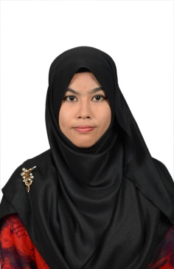

Personal Particular

**Name** : Siti Zulaikha Azwa Binti Mohd Hanafe

**Address** : No.10, Jalan BSE 4/21

Bandar Seri Ehsan

42700 Banting

Selangor

**Mobile phone number** : 011-3256 5034

**E-mail** : [zulaikhanafe96@gmail.com](mailto:zulaikhanafe96@gmail.com)

**National ID** : 960629-06-5142

**Age** : 20years old

**Gender**  : Female

**Date of birth** : 29st June 1996

**Place of birth** : Tanjung Gemok, Pahang

**Health** : Excellent

**Nationality** : Malaysian

**Religion** : Islam

**Marital status** : Single

**Height/Weight** : 170 CM/62KG

**Language** : Malay, English

**Interest** : Administration, Clerical, Human Resource

Career Objectives

* To be successful in an environment of growth and excellence and earn a job which offers me job satisfaction and self-development and help me achieve personal as well as organization goals.
* To hunt for challenging assignment and responsibility, with an opportunity for growth and career expansion as successful accomplishments.
* To be a professional and to utilize my skill and knowledge to satisfy the requirement of the organization in administration and/or human resources.
* To be an intelligent learner and the best performer in the organization.
* To excel in my field through hard work, skills and perseverance

Personal Qualities

* Integrity
* Hardworking
* Organized
* Trustworthy
* Good communication skills
* Positive attitude

Key Skills

* Advanced skill in the Microsoft Office (Words, Excel, Publisher, PowerPoint, and Access).

Education

2014-2017 College MCS, Banting, Selangor

(Current) Diploma in Office Administration

Current CGPA: 3.42

2007-2008 Sekolah Menengah Kebangsaan Bukit Changgang

Sijil Pelajaran Malaysia (SPM)

2004-2006 Sekolah Menengah Kebangsaan Bukit Changgang

Penilaian Menengah Rendah (PMR)

1997-2003 Sekolah Kebangsaan Rancangan Tanah Belia

Ujian Penilaian Sekolah Rendah

Work Experiences

**Café Barbara**

Temporary Work

Duties:

* Ensure clean plates and bowls
* Wrap food for customers
* Cleaning the Cafe Barbara
* Serve customers